State Machines
# Source: AI Source: Provided by: [Data Path: Persons Table -> ID Column: 1, Name_En Column: Motasem Essam] -> From: [ChatGPT] on [1/21/2026]
State Machines are a widely used modeling technique in Real-Time Systems (RTS) to describe how a system behaves in response to events or inputs. They are particularly useful for control systems, embedded systems, and reactive systems.

Definition
# Source: AI Source: Provided by: [Data Path: Persons Table -> ID Column: 1, Name_En Column: Motasem Essam] -> From: [ChatGPT] on [1/21/2026]
A state machine is a model that consists of:
- States – Different conditions or modes of the system
- Transitions – Rules for moving from one state to another
- Events/Inputs – External or internal signals that trigger transitions
- Actions – Activities performed during transitions or in states
It is also called a Finite State Machine (FSM) because it has a finite number of states.

Key Features
# Source: AI Source: Provided by: [Data Path: Persons Table -> ID Column: 1, Name_En Column: Motasem Essam] -> From: [ChatGPT] on [1/21/2026]
- States
  - Represent system conditions like Idle, Running, Waiting, Error.
- Transitions
  - Arrows connecting states, triggered by events.
- Events/Inputs
  - External signals (sensor input, user command) or internal events (timer, condition met).
- Actions
  - Executed when entering, exiting, or during a state.
- Deterministic Behavior
  - For a given input in a state, the next state is predictable.

Example
# Source: AI Source: Provided by: [Data Path: Persons Table -> ID Column: 1, Name_En Column: Motasem Essam] -> From: [ChatGPT] on [1/21/2026]
Consider a traffic light controller:
- States: Red, Green, Yellow
- Events: Timer expires
- Transitions:
  - Red → Green → Yellow → Red → …
- Action: Turn on the corresponding light
State Diagram:
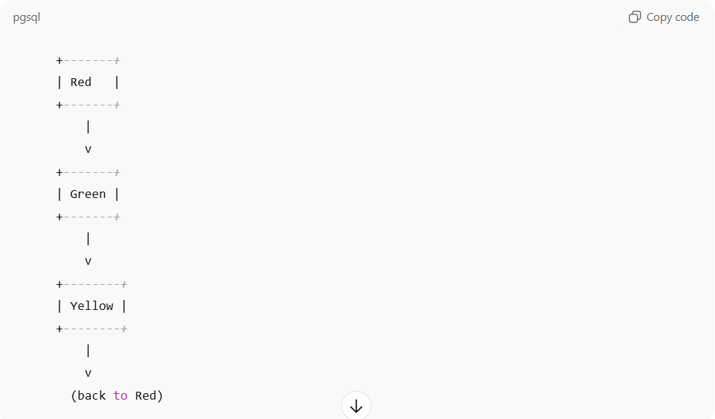
+-------+
| Red |
+-------+
|
v
+-------+
| Green |
+-------+
|
v
+--------+
| Yellow |
+--------+
|
v
(back to Red)

Advantages
# Source: AI Source: Provided by: [Data Path: Persons Table -> ID Column: 1, Name_En Column: Motasem Essam] -> From: [ChatGPT] on [1/21/2026]
- Clearly models event-driven behavior
- Useful for control systems and embedded software
- Easy to verify and debug system behavior
- Helps in code generation for real-time systems

Disadvantages
# Source: AI Source: Provided by: [Data Path: Persons Table -> ID Column: 1, Name_En Column: Motasem Essam] -> From: [ChatGPT] on [1/21/2026]
- Can become complex with many states and transitions
- Requires careful design to handle all possible events

Applications
# Source: AI Source: Provided by: [Data Path: Persons Table -> ID Column: 1, Name_En Column: Motasem Essam] -> From: [ChatGPT] on [1/21/2026]
- Traffic light controllers
- Elevator control systems
- Robotics and industrial automation
- Real-time user interface systems
- Embedded systems in avionics and automotive

